**Ideation Phase**

**Define the Problem Statements**

|  |  |
| --- | --- |
| Date | 17 September 2022 |
| Team ID | PNT2022TMID48692 |
| Project Name | Project - Real Time River Water Quality Monitoring System |
| Maximum Marks | 2 Marks |

**Customer Problem Statement Template:**

Create a problem statement to understand your customer's point of view. The Customer Problem Statement template helps you focus on what matters to create experiences people will love.

A well-articulated customer problem statement allows you and your team to find the ideal solution for the challenges your customers face. Throughout the process, you’ll also be able to empathize with your customers, which helps you better understand how they perceive your product or service.

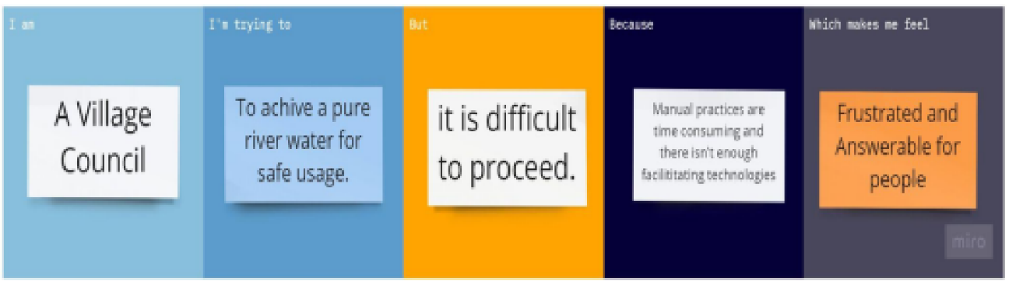

|  |  |  |  |  |  |
| --- | --- | --- | --- | --- | --- |
| **Problem Statement (PS)** | **I am (Customer)** | **I’m trying to** | **But** | **Because** | **Which makes me feel** |
| PS-1 | I am farmer. | I’m developing food and Forage crops. | But often get disappointed due to chemical imbalance in the water Supply from river. | Since use of fertilizers Itself produce necessary growth in crops the untreated river water Creates decay of crops which goes to waste. | It makes me to feel the clueless about my Farming technique s and survival. |
| PS-2 | I am villager who suffers from impure water issues. | I’m trying to take an initiative of consuming pure river water that prevent major and minor health issues in people. | But I can’t achieve due to that I can’t find proper method than manual practices or can’t find an apt product. | Because of poisonous state of water, we are unable to use it efficiently because it creates major and minor health issues to villagers. | It makes me frustrated and makes me answerable for the health and Risk factors that the villagers take. |